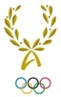

INTERNATIONAL OLYMPIC ACADEMY
52, Dimitrios Vikelas Avenue, 152 33 Halandri – Athens, Greece
62th International Session
for Young Olympic Ambassadors
Saturday, 11/6/2022 – Thursday, 23/6/2019

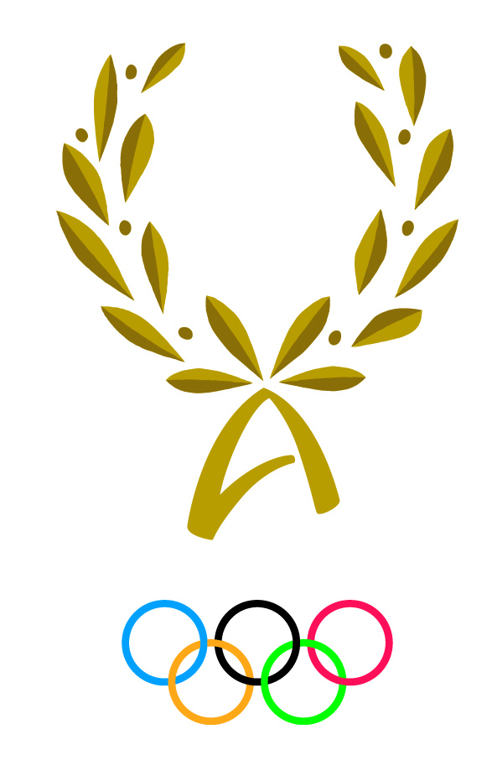
PARTICIPANT’S PERSONAL HISTORY FORM

Personal Details
National Olympic Committee/Academy:
Surname:
First name: Date of birth:
Nationality: Gender: Tel:
Address: E-mail:

Knowledge of languages
What is your mother tongue?
KNOWLEDGE OF IOA OFFICIALS LANGUAGES | READ |  | WRITE |  | SPEAK |  | UNDERSTAND
 | Easily | Not easily | Easily | Not easily | Easily | Not easily | Easily | Not easily
ENGLISH
FRENCH
GREEK

Which discussion group you would like to participate in: English-speaking group French-speaking group
Education (Give full details)
A. Secondary school, technical school or apprenticeship
Name of institution, place and country | Years attended |  | Degrees and academic distinctions | Main course of study
 | from | to
B. Bachelor education
Name of institution, place and country | Type | Years attended |  | Certificates or diplomas obtained
 |  | from | to
C. Postgraduate Studies
Name of institution, place and country | Type | Years attended |  | Certificates or diplomas obtained
 |  | from | to

Profession:

Sports career as an athlete:

Sports practiced in the past:

Sports currently practiced:

Awards:

Please indicate the associations or clubs of which you are a member:

Career as a sports official: (Please list duties assumed within a club or at regional, national or international level)

What is your particular interest in the field of sports:

REMARKS:

Why you wish to participate in the I.O.A. Session (Motivation letter)
(up to 500 words)

What are your initiatives after the end of the session. Include at least three of the following
1. Assist in implementing of minimum one programme with their NOC/NOA.
2. Disseminate knowledge and experience acquired in the Session at either a school, sports organization, or through social media platforms (reach needs to exceed 100 people).
3. Create or become part of minimum one network for the exchange of ideas, knowledge and information on Olympic subjects (e.g. become members of the IOAPA – IOA Alumni Network).
4. Create their own research, educational or work project which is related to the IOA, sports, Olympism, Olympic Games etc.
5. Make use of the various social media platforms in order to disseminate a. the experience they have acquired during the Session and b. the work/projects/programs they have undertaken after being inspired by their participation (e.g. by creating their own YouTube channel/vlog detailing their experience, or by creating content on Facebook, Instagram etc. during and after the Session).
(up to 500 words)

